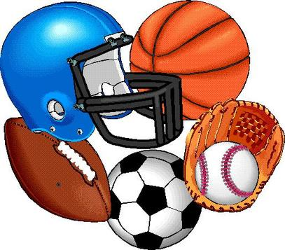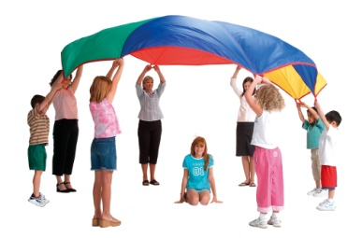
Lifetime/Team Sports
Syllabus

- Course Description/Objective
To increase the awareness and knowledge of lifetime and team sports concepts, skills, rules, and play that can be used to promote and enhance life-long participation and fitness through mastery. To introduce and develop higher level personal and social skills that can be used in daily life and adulthood. The following sports will be included in the course:
- Lifetime Sports: Golf, Tennis, Volleyball and Bowling
- Team Sports: Speedball, Flag Football, Soccer and Basketball

  - Important Information
Contact Info: (980) 343-6007 jonathanj.simmons@cms.k12.nc.us Monday @ 1:15pm

Coach Simmons has a bachelor’s degree in Physical Education and 6 years of teaching in Health and Physical Education. I am also an athletic coach with over 10 years of experience.

- Attendance and Daily Grade
- Daily attendance is very important in order to receive the greatest benefit from the class.
- If you are absent, you are responsible for making up any work missed within five days or the number of days the student was absent if more.
- 5 points for appropriate dress attire/5 points for full participation in group exercises & class activities.

- Make – Up Procedure
- Make up days can be earned for those with more than 10 absences. Each day is worth:
- Running one mile, 15 push-ups, 20 sit-ups, and 30 squats.

- Accidents and Medical Excuses
- If you are injured during physical education you need to report the injury to the teacher.
- Any student who is under a doctor’s care and is not able to participate must bring a written note from the doctor. Alternative activities will be provided.
- Written daily excuses from parents will only be accepted once!

- Gym and Locker Room Rules
- No horseplay of any kind at any time.
- No food, drinks, or gum allowed anytime.
- Respect yourself and others, i.e. no obscene language, gestures or harassment.
- Follow directions the first time they are given.
- No electronic equipment or cell phones allowed. This can result in a referral!
- No running in the locker room.
- Students are expected to take care of all equipment and see that it is returned to the appropriate place.
- No writing on the walls or lockers.
- No slamming of the lockers.
- Clothes and valuables may be locked in a locker, but must be removed after each class. Students are responsible for bringing a combination lock of their own. All clothes and personal items must be placed in a locker. We are not responsible!
- Incentives (Coach Simmons)
- Mini gifts and treats (High completion of monthly incentive worksheets)
- Gift Cards (Top male and female in each class)
- Pizza Party (Class with the highest dress percentage)

- Class Procedures
- You will have 10 minutes to dress. Classes leave the locker room at the same time and the locker rooms will be locked, therefore, late students without a pass will not be allowed to dress.
- Upon leaving the locker rooms, move to your assigned warm up area expeditiously for attendance and exercises.
- You will not be allowed to return to the locker room for any reason!
- Do not leave the playing area or gym without permission. This includes getting a drink of water.
- Students must arrive to and from designated participation areas in the teacher determined time period.
- You will have 10 minutes to dress back for class. Please remain in the locker rooms or gym until the dismissal bell rings.

- Negative Consequences Tardy Consequences
- First Offense: Verbal/Nonverbal warning 1. First Time: Warning
- Second Offense: Time Out 2. Second Time: School Consequence
- Third Offense: Student conference 3. Third Time: School Consequence
- Fourth Offense: Parental contact & contract 4. Fourth Time: Parental Contact
- Fifth Offense: Administrative referral 5. Fifth Time: Administrative Referral

- Uniform Regulations
- Physical education attire consists of athletic shorts, a T-shirt, and tennis shoes. (HUHS attire allowed)
- A jogging suit or sweat suit may be worn in cold weather.
- No jeans, jean shorts, dress pants, dress shirts, cut-off or sleeveless shirts, open shoes, or hard sole shoes are allowed. You may not wear the same clothes you wear during regular school time.
- Dress appropriately for the weather. We may be inside or out.
- Loose items of jewelry should not be worn.

- Grading System Grading Scale
- Formal (Tests and Quizzes) 70% 90-100% = A
- Informal (Dress/Participation & Projects) 30% 80-89% = B
70-79% = C
60-69% = D
0-59% = F

- - - - - - - - - - - - - - - - - - - - - - - - - - - - - - - - - - - - - - - - - - - - - - - - - - - - - - - - - - - - - - - - - - -

Please sign this portion and return to the instructor indicating that you have read and understand the rules and regulations for Physical Education.

________________________________________
Print Student Name

_______________________________________ _ ___________________
Student’s Signature Date

_______________________________________ _ ___________________
Parent’s Signature Contact Number

